SMILE

- Arunima Sharma, BVCOE

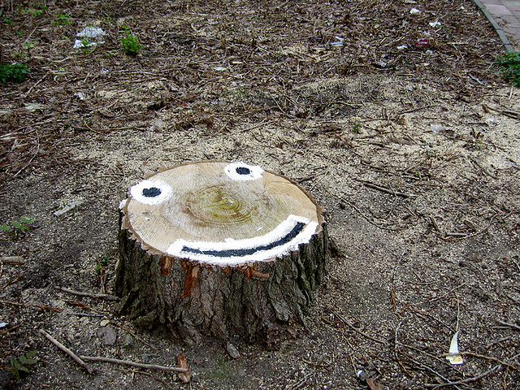

If you want to know my friend, why do I smile so much?   
Just fantasize yourself , stuck in a situation this tough,   
That life is your murderer, with a weapon of ‘problems’ here he comes,   
To take away the liveliness within, and make your soul numb.   
And then of course you analyze the situation, plan out to try and run,   
But oh, human! This track beneath your feet is such a swampy gum.   
  
There are two ways in which you can fight this bout of life,   
One is the one they choose in general, and the other is mine.  
The first- to fight with power and tricks of cruel selfish pride,   
The other- to have the innocent action of holding his hand and smile,   
For I know my friend that I will ultimately complete my span and die,   
So why should I fight with life via all my strength and fright?   
I may seem so different and stupid to you at times,   
But I prefer being pure at heart, just fighting through life with this SMILE!

